|  |  |
| --- | --- |
| **Name:** | Rishav Dugar |
| **Roll Number:** | 19IM3FP30 |

1. **Aim of the experiment**

To study about the signal handling and frequency response of the CE amplifier

1. **Tools used:**

Transistor with CE configuration, Resistors, Capacitors, Multimeter, Voltage Source ( AC and DC )

1. **Background knowledge (brief):**

A bipolar junction transistor, BJT, is a single piece of silicon with two back-to-back P-N junctions. BJTs can be made either as PNP or as NPN. It is a solid-state current-controlled device which can be used to electronically switch a circuit, you can think of it as your normal Fan or Light switch, but instead of turning it on manually it can be controlled electronically. Technically speaking, BJT is a three-terminal device with an Emitter, collector, and a base pin, the current flow through the emitter and collector are controlled by the amount of current applied to the base. The BJT is formed by three layers of semiconductor materials.

It is of two types:

● PNP transistor: it will have two P-type regions and one N-type region

● NPN transistor: it will have two N-type regions and one P-type region.

The two outer layers are where the collector and emitter terminals are fixed and the base terminal is fixed at the center layer.

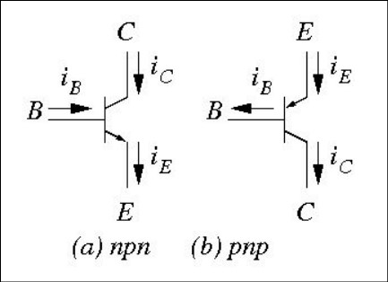

BJT can be connected in three different configurations by keeping one terminal common and using the other two terminals for the input and output. These three types of configurations respond differently to the input signal applied to the circuit..

The three different configurations of BJT are listed below:

● Common Base (CB) configuration

● Common Emitter (CE) configuration

● Common Collector (CC) Configuration

BJT’s are used in a discrete circuit designed due to availability of many types, and obviously because of its high transconductance and output resistance which is better than MOSFET. BJT’s are suitable for the high-frequency application also. That’s why they are used in radio frequency for wireless systems. Another application of BJT can be stated as a small-signal amplifier, metal proximity photocell, etc.

1. **Circuit (hand drawn/image)**

For Signal Handling,

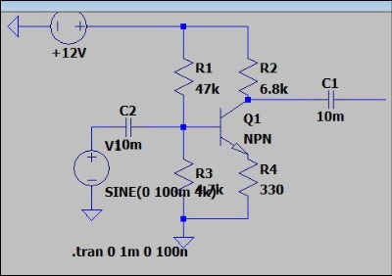

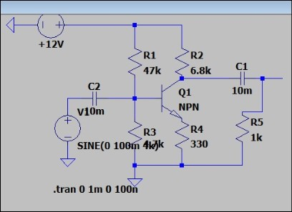

Load Rl disconnected Load Rl connected

For frequency response

Load Rl disconnected Load Rl connected

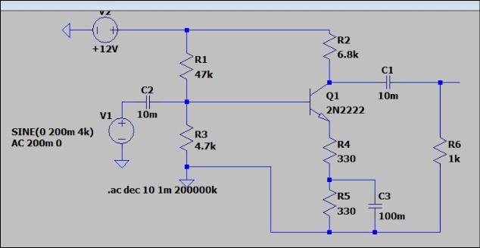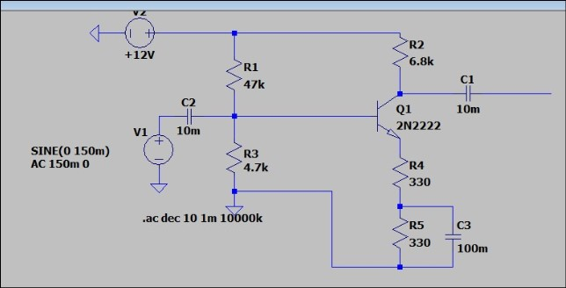

1. **Measurement Data (Tabular form)**

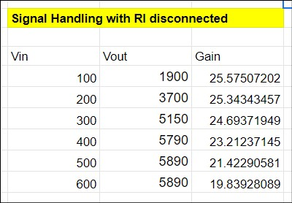

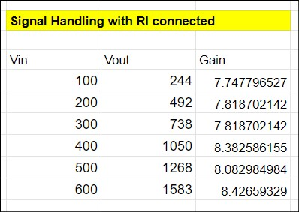

1. **Graph (Image)/Screenshots**

For Signal handling with load resistance disconnected

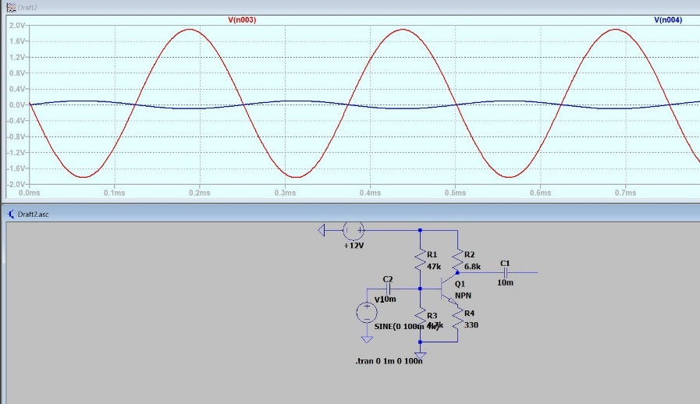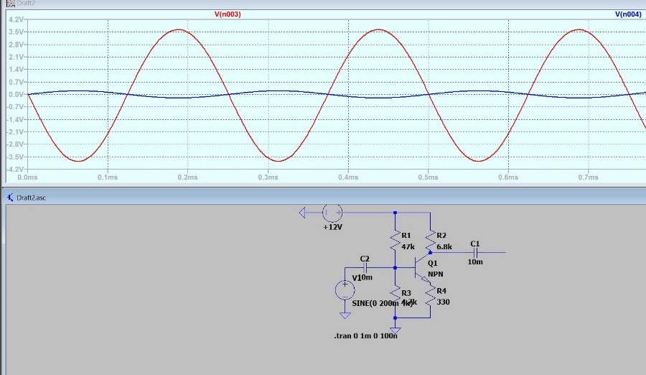

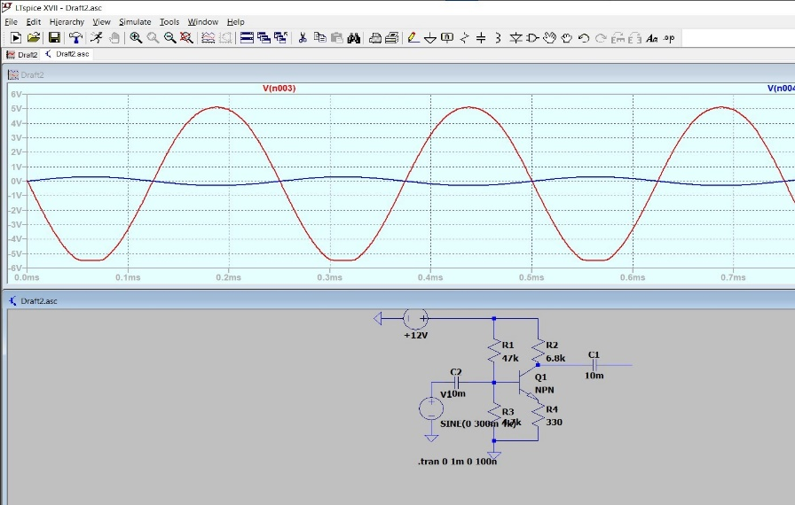

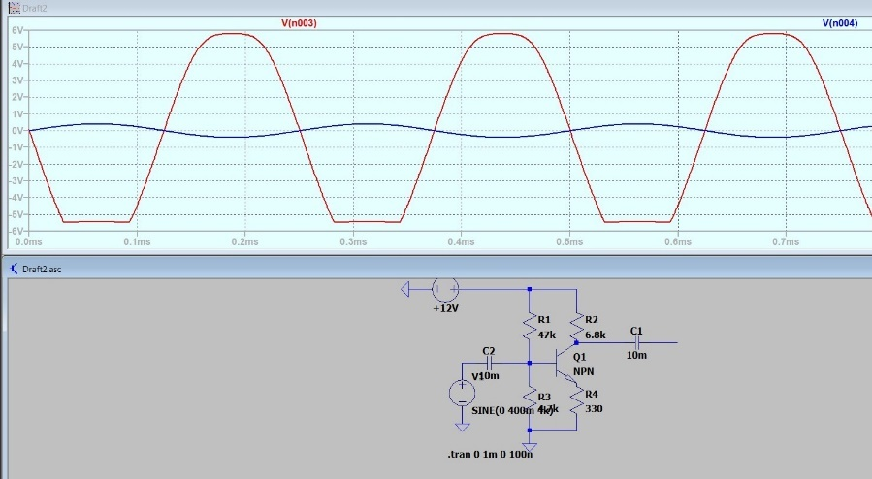

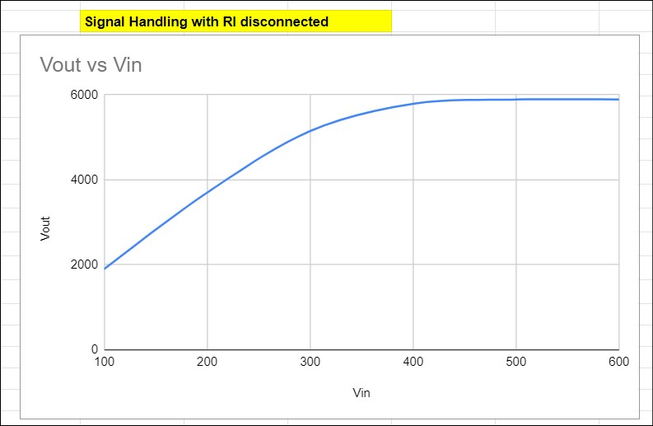

For Signal handling with load resistance connected

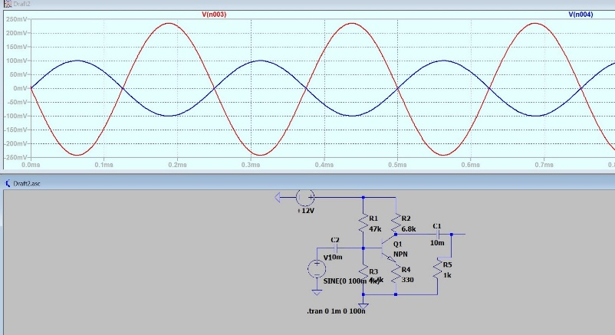

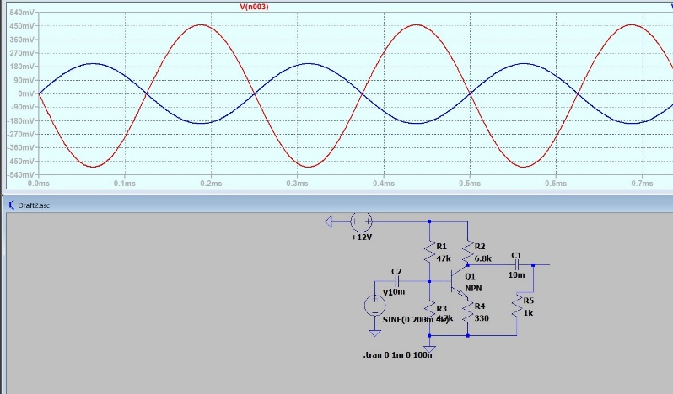

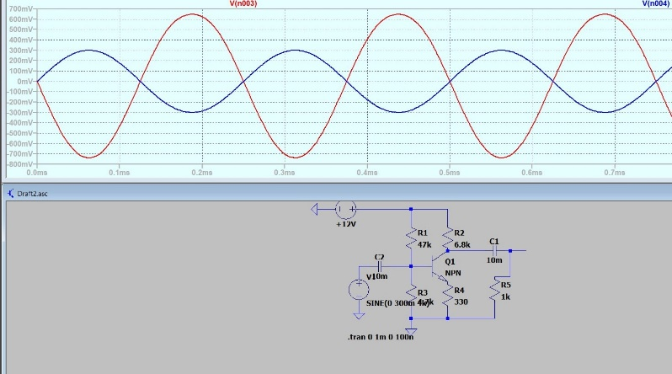

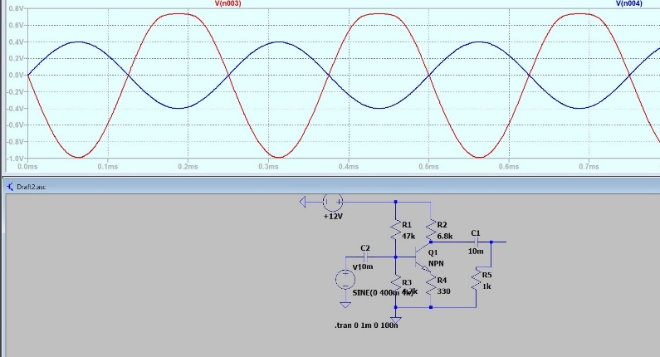

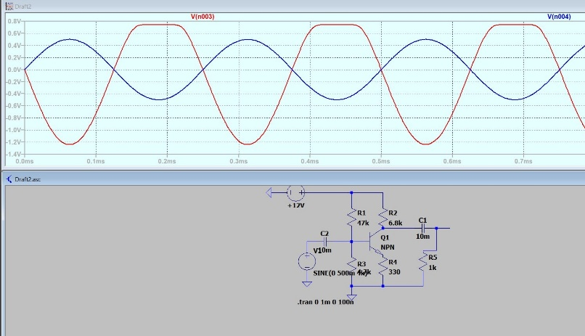

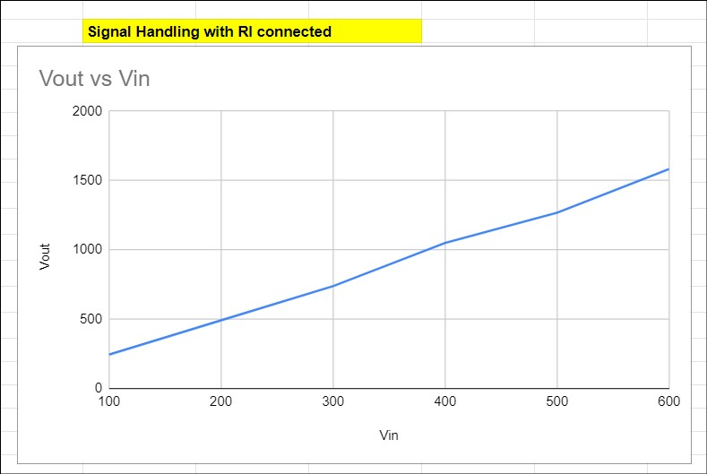

Frequency Handling

With load resistance disconnected

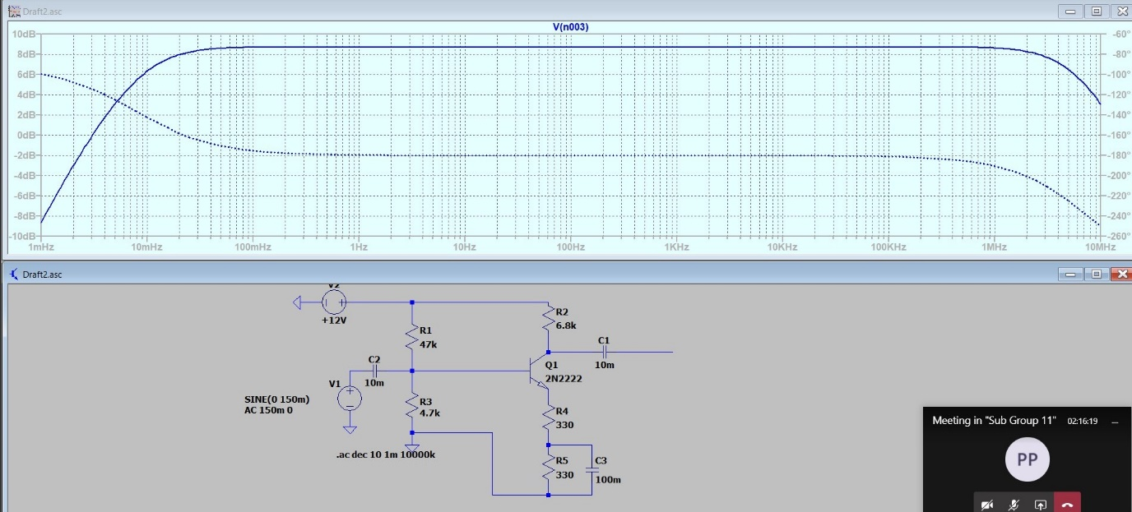

With load resistance connected

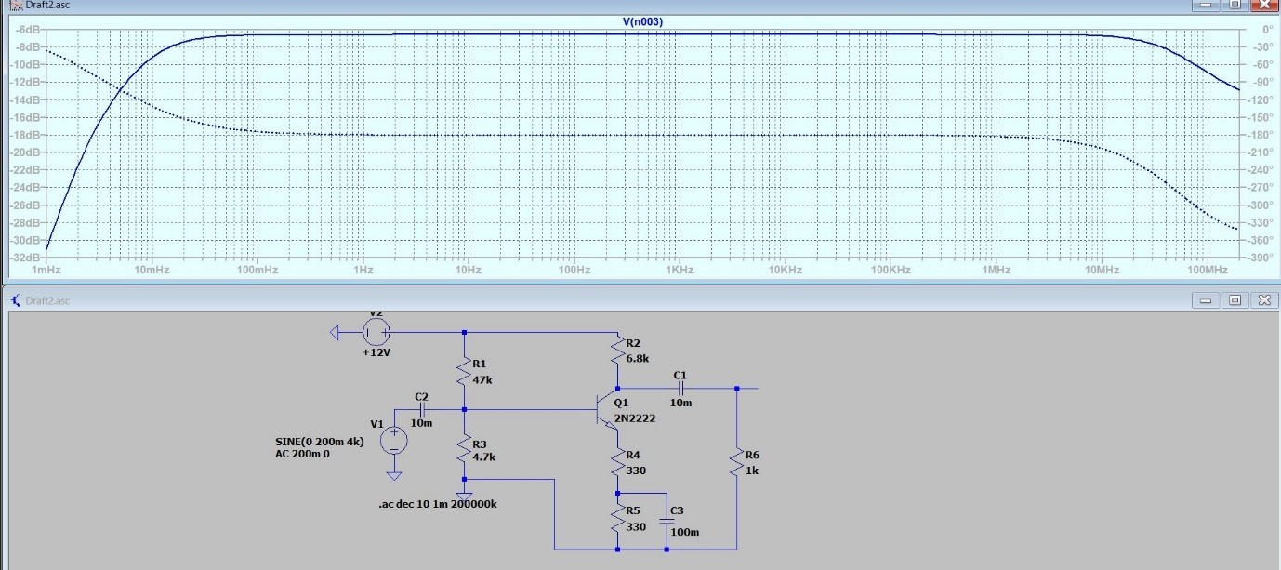

1. **Conclusion**

From signal handling experiment we get

Vsm = 300mV …. Load resistance disconnected

400mV …. Load resistance connected

From frequency response

With load resistance: fl = 8.97 mHz

fh = 67.02 MHz

Without load resistance: fl = 8.5 mHz

fh = 6.1 MHz

With the load resistance voltage gain is reduced.

1. **Discussions**

1: In a bipolar transistor which region is wider and which region is thinner and why ?

Ans: The middle region of bipolar junction transistor is called as the base of the transistor. Input signal of small amplitude is applied to the base thus this region is thin and lightly doped. The magnified output signal is obtained at the collector thus this region is thick and heavily doped.

2: Define current gain in CE configuration?

Ans: The current gain (β) of common emitter configuration is defined as the ratio of change in collector current to change in base current when collector emitter voltage is kept constant.

3: What are the three types of configuration in transistors?

Ans: Depending on the input, output and .common terminal a transistor are connected in 3 configurations: i) Common base configuration ii) Common emitter configuration iii) Common collector-Configuration.

4: What is collector reverse saturation current?

Ans: The reverse saturation current is the current due to the minority carriers flowing through the collector junction when it is connected in reverse bias.